Chapter 10, Problem 33.

Compute I in Prob. 10.15 using mesh analysis.

Chapter 10, Problem 15.

Solve for the current I in the circuit of Fig. 10.64 using nodal analysis.

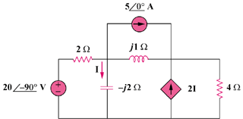

Figure 10.64
For Probs. 10.15 and 10.33

